**Fama-French Asset Pricing Model on Portfolio A**

The Fama and French Three-Factor Model, often known as the Fama French Model, is an asset pricing model that builds on the capital asset pricing model (CAPM) by including size risk and value risk elements in addition to the market risk factor that is present in CAPM. It was created in 1992. This model takes into account the recurring outperformance of markets by value and small-cap stocks. The model corrects for this tendency to outperform, which is expected to improve its usefulness as a tool for assessing management performance. Today I will be discussing about a single portfolio as follows.

**Portfolio A**

|  |  |
| --- | --- |
| **Stock** | **Weights** |
| JPM | 72% |
| BTC | 28% |

In portfolio A, we buy stock JPM and BTC . Portfolio A has credit risk. In general, credit risk depends on financial ability to repay obligations. For example, the credit risk is significantly high in companies with poor performance. As only two stocks are involved in this portfolio, asset diversification is less which leads to credit risk. On the other hand, credit risk is mainly due to price fluctuations which increase with the levels of uncertainty. If the stock prices increase unexpectedly, we will face losses. Therefore the risk of loss arising from the failure is high

Average return of the portfolio for the five year period is 100.19 % . According to the Correlation Matrix of daily returns, Correlation coefficient between JPM & BTC is 0.116031. Correlation is the statistical measure of diversification. Theoretically, more diversification can be observed when stocks are uncorrelated or negatively correlated with one another. However, portfolio A has a positive correlation which shows that both stocks JPM & BTC move together, as one increases, the other also increases. In other terms, diversification of this portfolio is risky. Diversification will help to maximize returns while minimizing the risk.

Portfolio A cannot be considered a diversified portfolio. A diversified portfolio has a combination of various stocks. Here we are working with only two. But in terms of sector, we can say the portfolio is diversified having assets from cryptocurrencies and stocks. Comparison of the Portfolios in terms of risk can be done using the Coefficient of Variance Portfolio Coefficient of Variation comparison Portfolio. For this case portfolio A has a higher variance 10.08%



When we buy a stock there is a guarantee at least for our invested capital. This is highly connected with the economic growth rates. Reportedly, the growth in economies is slow due to various reasons including COVID pandemic, Ukrainian war, ongoing financial crisis etc… Therefore shorting stock can lead to unlimited losses. On the other hand, the risk of a buying stock is limited by the price of the stocks that we purchase. Moreover, in general, stocks tend to rise over time. Therefore when shorting stocks, time management should be carefully addressed, otherwise the overall trend will be against us. Additional costs such as stock borrowing costs and dividend payments are involved with buy stocks. We have to make sure that these costs do not exceed the profits that we make out of buying or shorting (weights changing to negative).

Implementing monetary policies and guidelines is also an important factor in risk assessment. This will control the money supply which indirectly helps to control inflation. Inflation risk increases as the portfolio’s buying power will not keep up with inflation. Therefore maintaining diversification and managing the risks is highly required. Fluctuations in prices will affect the net returns of the portfolio. Long positions will suffer in unexpected price changes while short positions will obtain limitless losses.

Trading provides liquidity to the portfolio. However, hedging is required to protect the stock and minimize the risk of declining stock price in the future. We can also look into diversifying the portfolio efficiently so that we can maximize the returns while minimizing the risks. Buying various types of stocks with different performance levels gives us more opportunities and at the same time reduces the volatility in the portfolio. To enhance the performance of the portfolio, managing our expenses is a crucial factor. Lowering the expenses by the smallest possible percent will give impressive net returns to the portfolio.

A good portfolio is not always the one with the highest return. The performance of a portfolio is determined by the way we balance the risk and the returns made on the investment. Sharpe ratio, which is the ratio of excess returns and the standard deviation of the portfolio, is a good measure of the risk-return relationship. If this ratio is high for this case a sharp ratio of 3.16% , it reflects that the portfolio significantly performs well.

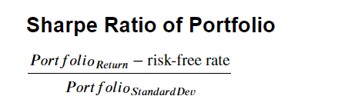 Central banks fix the interest rates in the economy. This is greatly affecting the behavior of borrowers and lenders. Lower interest rates encourage borrowing money. But once the rates rise back, there will be negative consequences. Central Bank interferes in the local foreign exchange market through the supply and absorption of foreign currency. Regulatory barriers and policy changes over time intervene in the consistency of the performance of a portfolio. Investment banks match sellers and investors, therefore adding liquidity to markets. Stock market share changes rapidly due to many reasons. Investment banks act as financial advisors. They work as intermediates between the stock issuers and the investors. Investment banks analyze the market environments and identify the best options to invest in. Therefore there are high earning probabilities. Additionally, investment banks have powerful interactions in the market. Therefore, it enables new opportunities and protects you from challenges. Hence, the risk of your investments is low.

**Portfolio Return vs Individual Stocks**

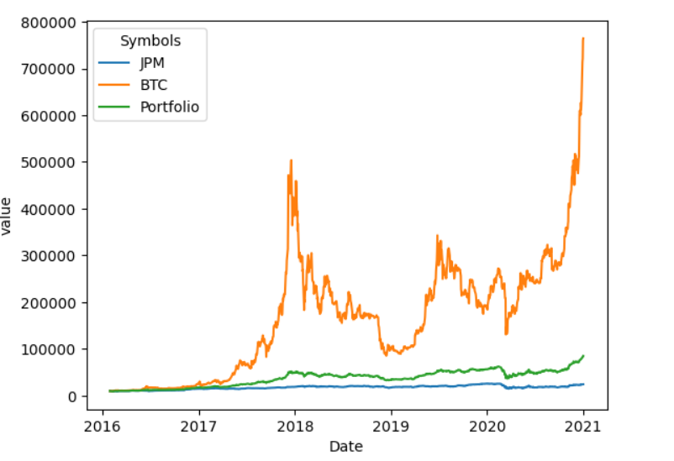

Portfolio A has a higher standard deviation 0f 31.75 suggesting high volatility in the portfolio. This can be seen from the Bitcoins graph which is the most volatile. But JPM not quite that volatile. A combination of the two is the best in terms of diversification in regard to volatility.

The returns also seem to show OLS assumption of a linear relationship as shown in the chart below but having fatter tails.

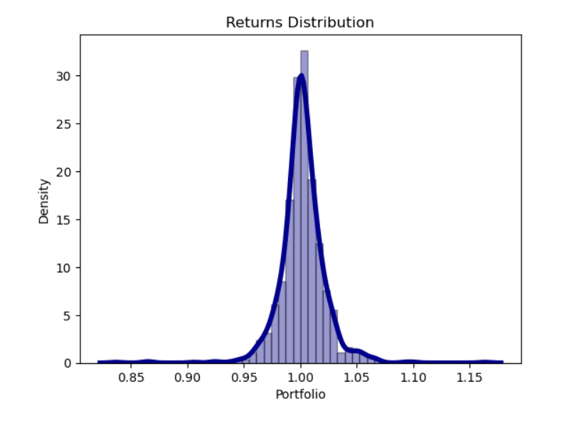

The returns for the five years seem to have a constant variance thus confirming homoscedastic feature. They are all concentrated around 1.0 and are uniform across.

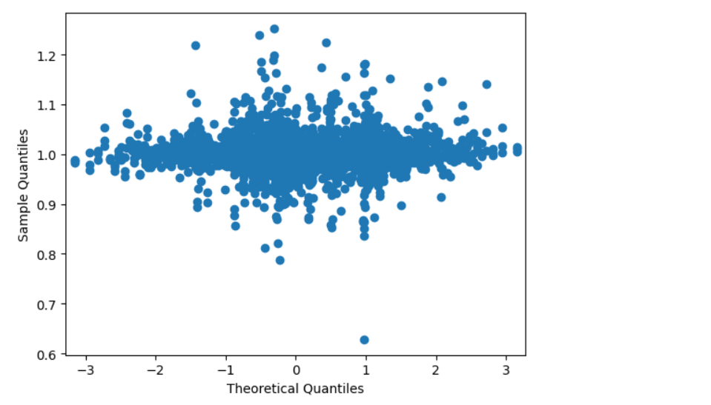

Comparing the weighted return of the portfolio before 2021 and after 2021 we can see despite the covid pandemic effect of 2021, The year still had the highest weighted return of 100.29% compared to the average weighted return for the last five years before 2021 of 100.19% this is unexpected but can be explained by the effect of having cryptocurrency (Bitcoin) which performed so well till the end of 2021 in our portfolio. In addition, we can see for the period 2021 the weight for Bitcoin raised to 92% while that for JPM reduced to 8%. This move was quite a productive one by creating a balance in our portfolio

**References**

* Investment Performance Measurement Errors, accessed 2008-06-29
* Markowitz, H.M. (March 1952). "Portfolio Selection". The Journal of Finance 7